**Lab 4 – Ben Joye**

**9/20/18**

**Requirements Analysis:**

**Functional:**

* The user must be able to able to input which implementation to use so that the right constructor is called.

**Non-Functional:**

* Both implementations must have an add function.
* Both implementations must have a pop function that returns the first value in the list.
* Both implementations must have a function that returns the size of the list.
* The system must be able to handle a list of up to 100 values.
* The system must print list in the correct order to the console.

**Design:**

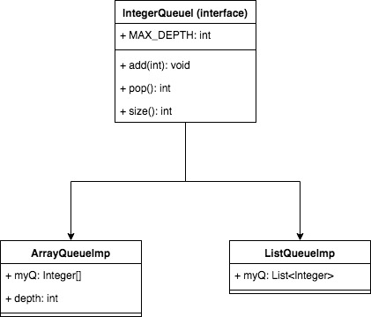

**Testing:**

* Input: 1
  + Output: 42 17 37 36 12
* Input: 2
  + Output: 42 17 37 36 12

**Deployment:**

* On unix:
  + Compile: “make”
  + Run: “make run”